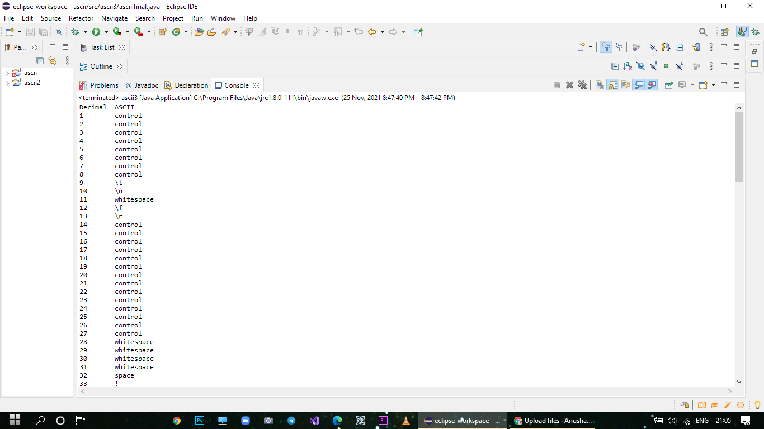

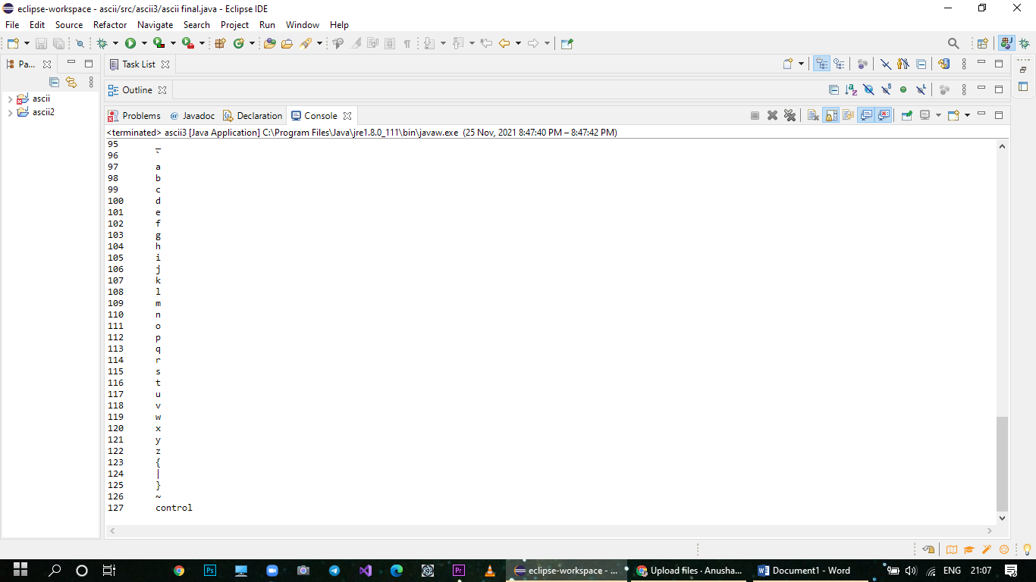

**package** ascii3;

**public** **class** ascii3 {

**public** **static** **void** main(String[] args) {

System.***out***.printf("%1$-8s %2$-10s \n", "Decimal", "ASCII");

**int** min = 1;

**int** max = 128;

**for** (**int** i = min; i < max; i++) {

**char** ch = (**char**) i;

String display = "";

**if** (Character.*isWhitespace*(ch)) {

**switch** (ch) {

**case** '\r':

display = "\\r";

**break**;

**case** '\t':

display = "\\t";

**break**;

**case** '\n':

display = "\\n";

**break**;

**case** '\f':

display = "\\f";

**break**;

**case** ' ':

display = "space";

**break**;

**default**:

display = "whitespace";

**break**;

}

} **else** **if** (Character.*isISOControl*(ch)) {

display = "control";

} **else** {

display = Character.*toString*(ch);

}

System.***out***.printf("%1$-8d %2$-10s \n", i, display, Integer.*toHexString*(i));

}

}

}